Risk management in Consumer Retail

Companies Considered:The Company considered is Sears (SHLD). Even though there are many consumer retail companies, the closest competitors to Sears in terms of structure and competencies are JC Penny (JCP), Macy’s (M) and Target (TGT).

## Analyzing operational risk using Income Statements:

By projecting income statements of 5 years from 2012 to 2016 up to 2027 we forecast the Total present value and Terminal value % of each company. The income statement looks at the major internal factors affecting a company. The beta and growth rates are from expert opinions in the retail industry. The projected income statements and risk simulations for the 4 companies are embedded below.



Simulation charts for Total value and Terminal growth percentage for the four companies follow.

The charts are summarized in the table below:

|  |  |  |
| --- | --- | --- |
| Company | Mean Total value | Mean Terminal value % |
| SHLD | $-3.48 | 26.73% |
| JCP | $-4.65 | 41.21% |
| M | $19.03 | 44.36% |
| TGT | $50.90 | 50.65% |

*\*All figures in billion*

The companies are arranged in increasing order of Mean Total value. It is notable that the contribution of the Mean Terminal value to the Mean Total value is also increasing.

**SHLD:**

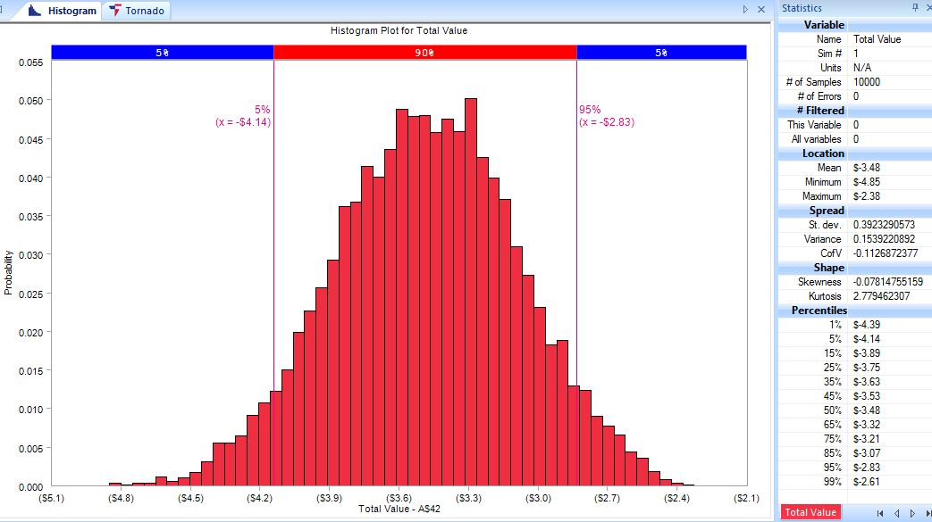

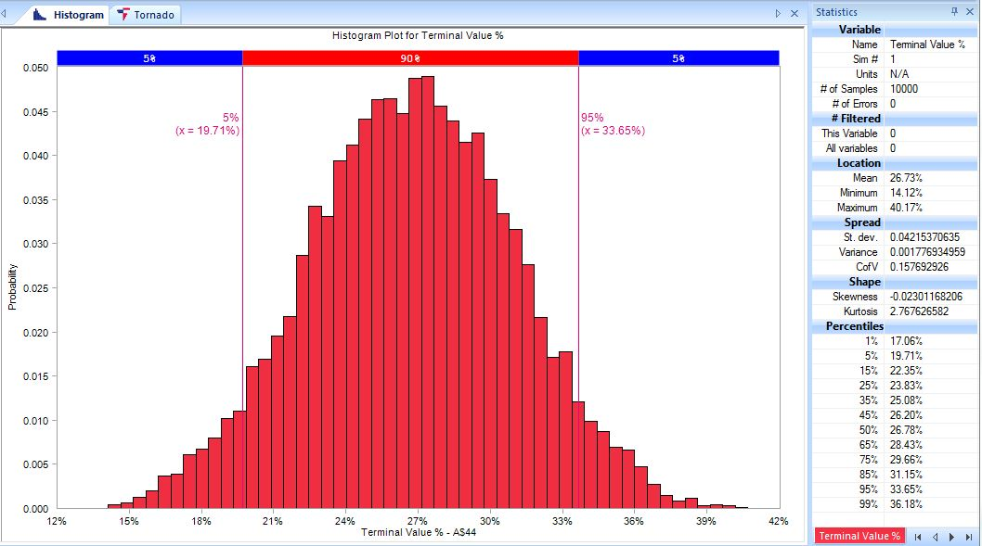

**JCP:**

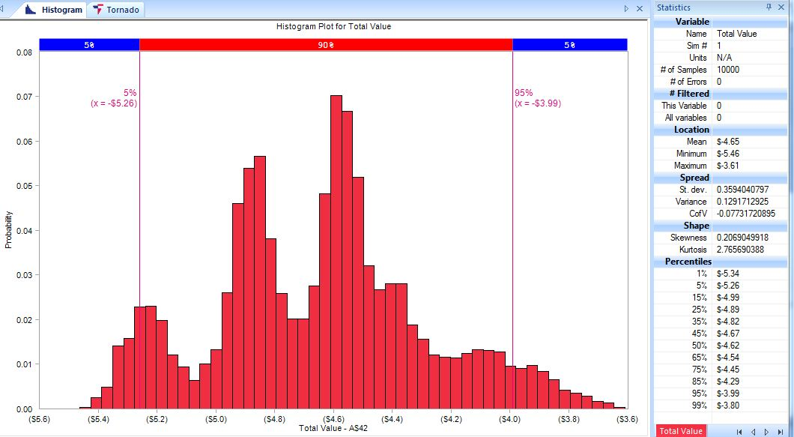

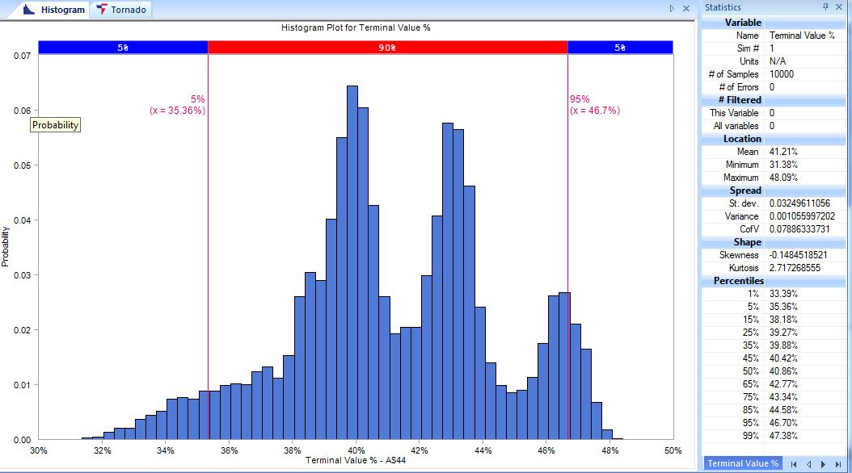

**M:**

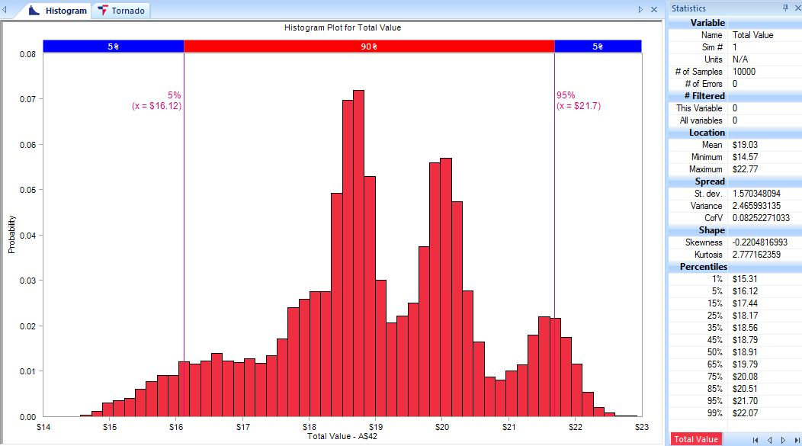

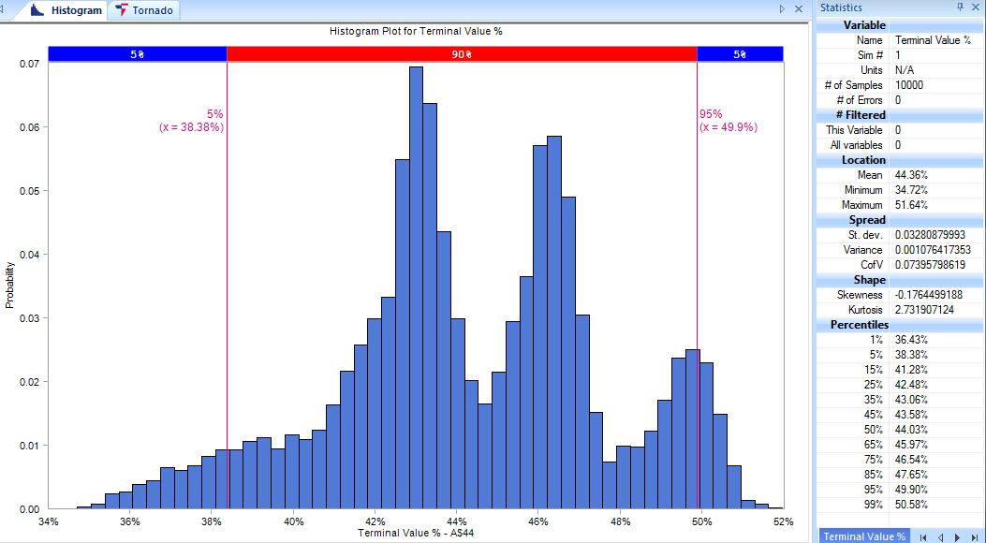

**TGT:**

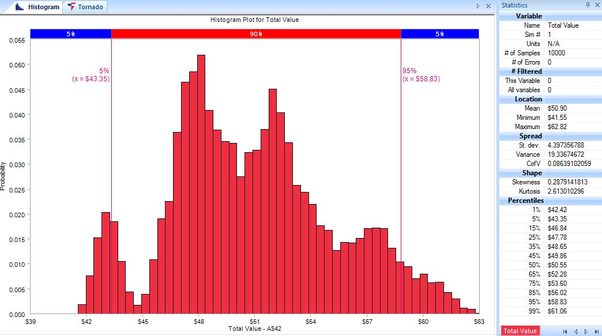

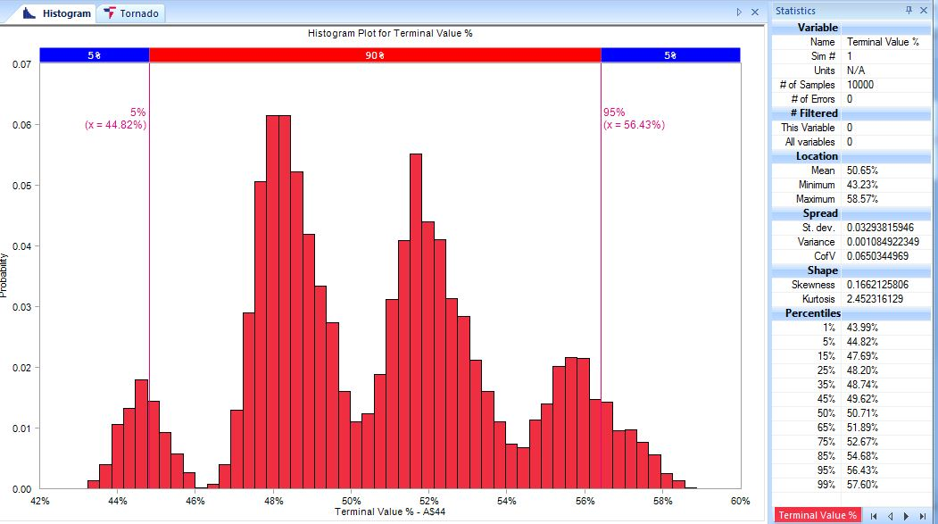

**Check sensitivity of income statement parameters:** We find the correlation between Terminal Value% and Beta and Terminal Value% and Terminal Growth using a Tornado graph.

**SHLD:**

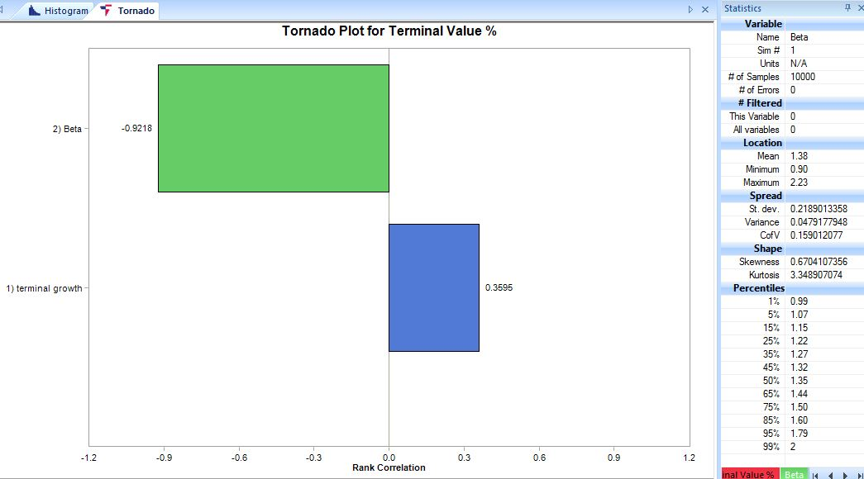

**JCP:**

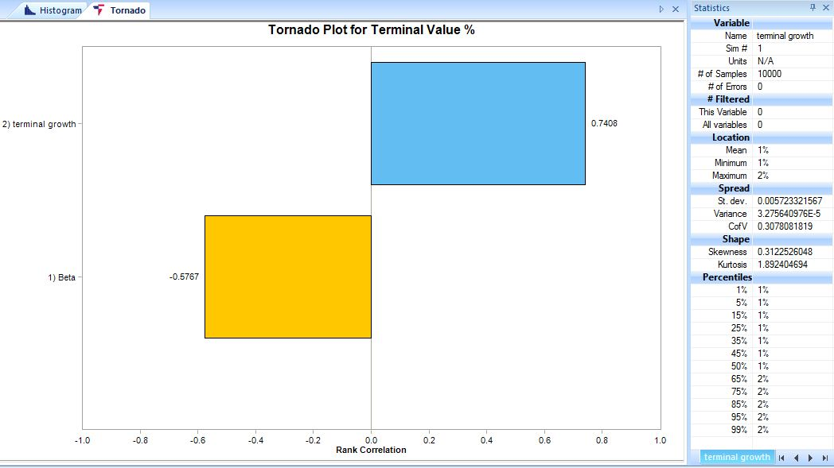

**M:**

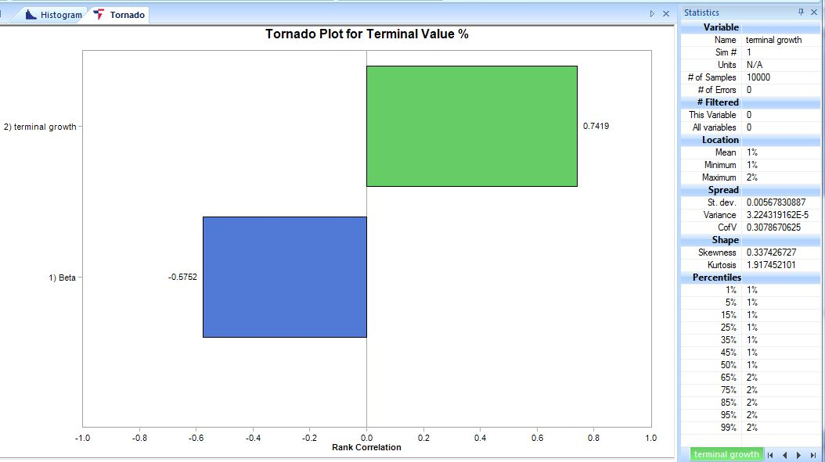

**TGT:**

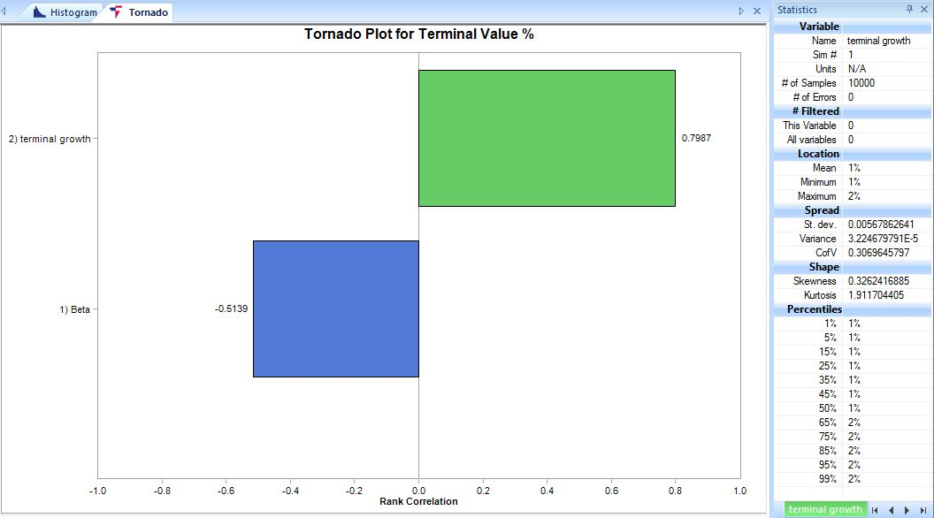

The Terminal Value % (percentage of Terminal value to Total value) is used as it forms a significant portion of the Total value. The mean beta and Terminal growth for the four companies are as below:

|  |  |  |
| --- | --- | --- |
| Company | Mean Beta | Mean Terminal Growth rate |
| SHLD | 1.38 | 1% |
| JCP | 0.87 | 1% |
| M | 0.87 | 1% |
| TGT | 0.68 | 1% |

From the above, we see that SHLD has the highest beta as its operational performance has not been profitable. Others companies have lower betas with TGT being the lowest as it has been doing well in terms of profitability. This is also reflected in the Tornado graphs. SHLD Terminal Value% is highly negatively correlated with Beta with terminal growth having low correlation whereas for other companies the Terminal Value% is highly positive correlated with Terminal growth with beta having a comparatively low correlation.

A notable fact is that all companies have a mean terminal growth rate of 1%. This is because all traditional retail companies have been affected by external factors such as the e-commerce boom, rising costs, changes in consumer spending patterns, import taxes etc. The GDP growth rate is around 3%. Most companies cannot grow beyond the GDP growth rate. Since consumer retail climate is not good now a mean terminal growth of about 1% can only be expected.

Analyzing the Financial risk using Value at Risk (VaR): The returns are calculated as LN(x)t+1/LN(xt) where (x)t+1 is the return at time t+1 and (xt) is the return at time t. The analysis for the four companies in the sheet below:



We calculate the 95% VaR and 99% VaR for each company. The 95% VaR means that there is a 95% chance that the losses in a portfolio will not exceed the estimated amount within a certain time frame—for example, a month, or a day in this case; this corresponds to the fifth percentile of the price change distribution in that specific period. Similarly the 99% VaR corresponds to the first percentile. We can do these using 3 approaches as below.

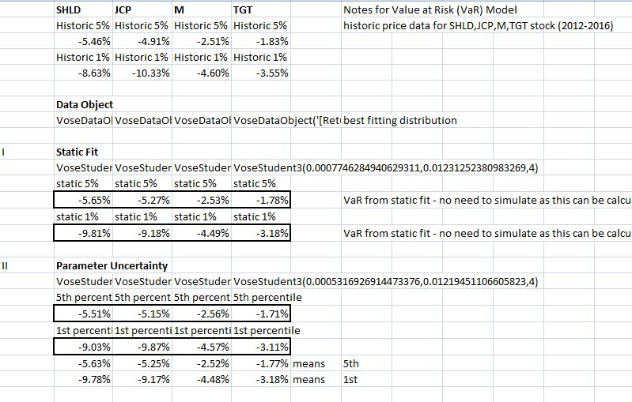

An initial estimate would be to directly use the percentile formula on the historic returns. Then we move on to the first approach which fits a distribution to the data object made from the data. Here Student3 fits the data best based on the information criteria given by Risk. The second approach would be to model parameter uncertainty in a distribution.

From the above results we see that for all the three approaches SHLD and JCP have a greater VaR compared to others. M is better than SHLD and JCP whereas TGT has the least VaR. This indicates that TGT has the least risk among the four.

Another layer of uncertainty can be added – model uncertainty. This approach has been done for SHLD. Five distributions which closely fit the returns data are as seen below. Bayesian Model Averaging (BMA) is a technique that permits a number of distributions to be used in a Monte Carlo simulation, weighting them according to how well they fit the actual data. If we have any prior beliefs regarding the relative weights of a distribution we can place them in priors – here all are equal.

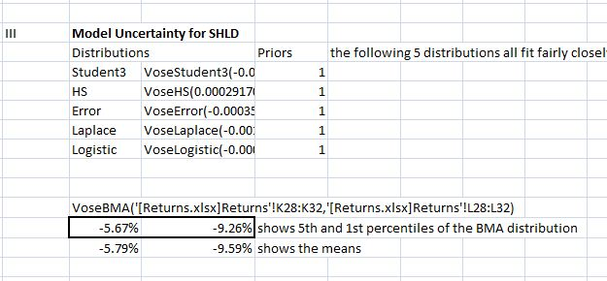

This approach closely matches the VaRs obtained for SHLD from the previous approaches.

Now, let us assume that we are investing $1000 in SHLD stock. To compute the 1-day VaR, we simulate the first and fifth percentiles of the portfolio values after the simulated day and subtract these amounts from the initial capital. We also compute the size of the loss, the conditional VaR (cVaR), and the two worst-outcome days that might occur over the next year. The conditional VaR shows the expected loss, conditional on a loss greater than the VaR threshold. In other words, it is the mean of the outcomes that is worse than the VaR estimate. This is a form of stress testing to see how much the loss can go to. We see below that the maximum loss can go up to $115.

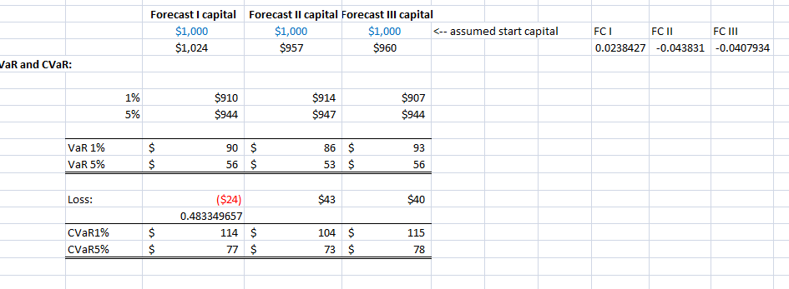

The below box plot shows that the variance doesn’t change much in the three scenarios and means are also almost similar.

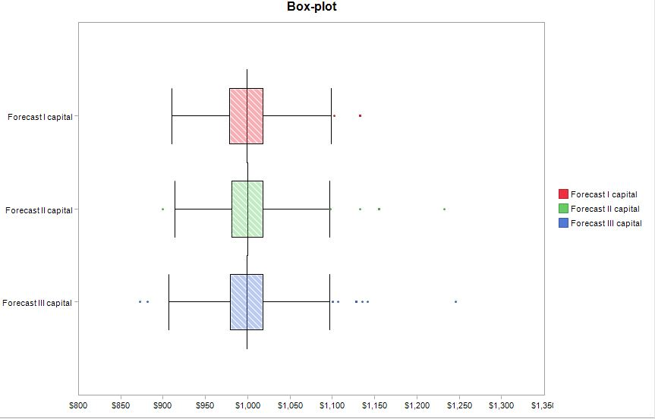

The below is the box plot for the 3 methods used -1st order, 2nd order and BMA at 1%.

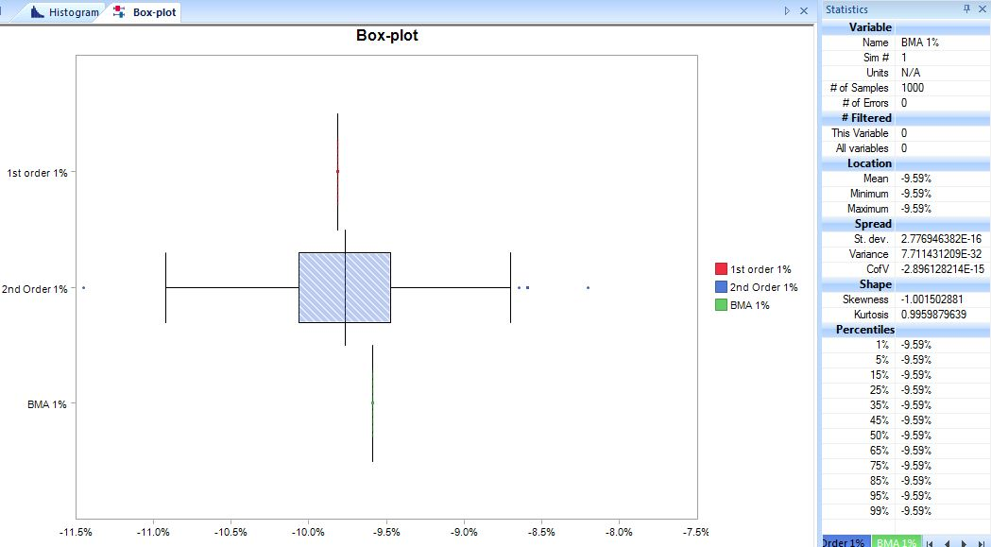

The first order VaR for 1% is no longer uncertain and is 9.81%. In second order there is uncertainty ranging from -10.3% to -9.6%. The BMA 3rd order also does not have much uncertainty and is 9.59%. This may be because the variance drastically reduced.

We have also calculated the worst and second worst daily price changes expected over the next year. For this we use the Kth smallest function.

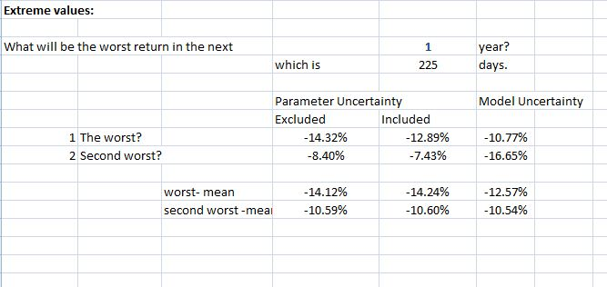

The worst mean for SHLD can go up to -14%. Since there is a variation in VaR, we should keep in mind that capital inadequacy cannot be judged by the mean value of the first percentile or the value of the first percentile alone.

Modeling Relationships: Regression and copulas are the methods used to model the relationship between variables – an important consideration for investments.

**Fitting line equations for Beta – a form of regression:** As discussed previously, Terminal growth rates are usually assumed to equal the long-run expected growth rate for the economy, which is generally thought to be around 3%. Sustained growth rates above this level are typically not realistic and should be associated with increased risk—in other words, with higher values for Beta. For each of the terminal growth rates, we solicited a minimum, most likely, and maximum value for Beta that would be appropriate for SHLD.

***Relationship between Terminal Growth and Beta for SHLD***

|  |  |  |  |
| --- | --- | --- | --- |
|  | beta | | |
| terminal growth | **minimum** | **most likely** | **maximum** |
| 1.00% | 0.89 | 1.25 | 1.75 |
| 2.00% | 0.93 | 1.28 | 2.00 |
| 3.00% | 1.00 | 1.42 | 2.28 |

. The sheets below have the analysis.



Regression is used when one of the variables is uncertain. As explained above, we know the growth rates expected. So, we take growth rate as x (independent variable) and beta as y (dependent variable).

The quadratic equations obtained for the 3 scenarios are as below

The 3 betas are then calculated using the above equations and the growth rate obtained from the PERT distribution. The final beta is then calculated using the PERT distribution. Using this beta and growth rate the total value is again computed. The mean total value obtained is -$3.22 billion which is similar to the value of -$3.48 billion obtained from the previous approach (income statement explained on page 1). However, the terminal value% is different. This approach gives 24.16% whereas the previous approach gives terminal value% of 26.73%.

**Copulas:** Using the income statement projections, we looked at the internal factors affecting each company. The stock prices of a company reflect the external factors that affect a company. In this project, we are looking at consumer retail companies which are close competitors. This means that the companies are quite similar to each other. To account for this similarity, we need to find the correlation between the returns of these companies. As previously mentioned, the returns are calculated as LN(x)t+1/LN(xt) where (x)t+1 is the return at time t+1 and (xt) is the return at time t. However, returns are random variables and hence follow a distribution. The most appropriate distribution for the four companies considered is the Student3 distribution. To find the relation between the returns of the four companies, we fit a copula to the Student3 distributions fitted for the returns.

The analysis is present in the sheets below:



We fit a Multivariate copula as we have 3+ returns. Based on the information criteria, the most appropriate copula for the returns data we have is the T copula. We simulate the fitted copula object which is then used in the simulated values of the distribution. We then obtain the total return for 25 days (since we used daily stock data) by summing the simulated values.

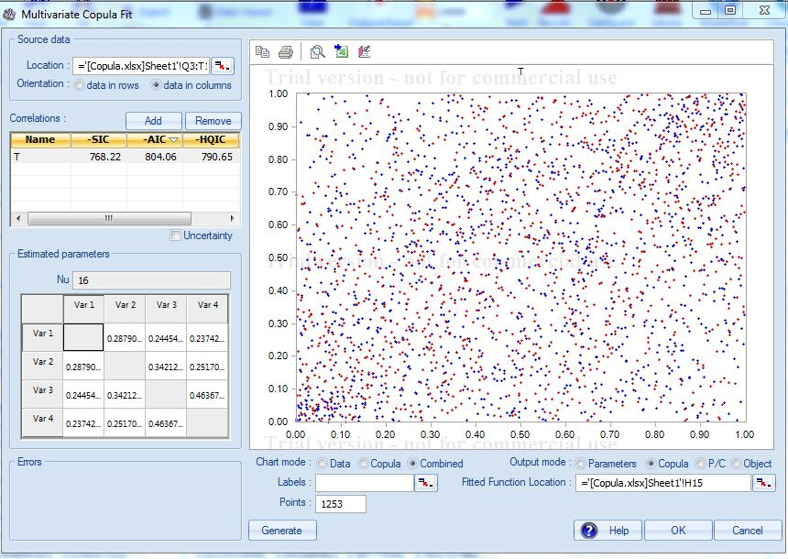

In the above figure we see the correlations given by the copula which is displayed in the table below:

|  |  |  |  |  |
| --- | --- | --- | --- | --- |
|  | SHLD | JCP | M | TGT |
| SHLD | 1 | 0.28790 | 0.24454 | 0.23742 |
| JCP | 0.28790 | 1 | 0.34212 | 0.25170 |
| M | 0.24454 | 0.34212 | 1 | 0.46367 |
| TGT | 0.23742 | 0.25170 | 0.46367 | 1 |

From the table above, we see that the correlation coefficients are not very high. But amongst the returns of the 4 companies, the strongest correlation is between Macy’s (M) and Target (TGT) which is 0.46367.

The total returns are run through a simulation to obtain the expected total return in 25 days.

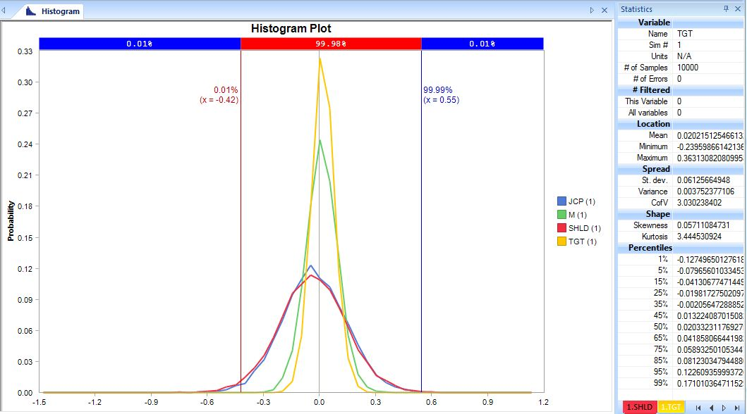

|  |  |
| --- | --- |
| Company | Total return |
| SHLD | -0.0348 |
| JCP | -0.0258 |
| M | 0.0119 |
| TGT | 0.0202 |

As per the plot and mean returns obtained, TGT gives the highest return and SHLD gives the lowest.

## Portfolio Optimization using Opt Quest:

Using an example provided by @Risk, I have used the Opt Quest feature to determine the optimum fractions to be invested in each stock. The model optimizes for a portfolio return after 25 days. The portfolio is restricted so that no more than 75% can be held in one stock, and the coefficient of variation for total return is below 30%. I have also added a constraint that the sum of the fractions shouldn’t be greater than 1. These constraints are used to ensure a balance between risk and return.

The above table gives us an idea about what the starting values for the optimization should be. The fractions are obtained using Opt Decision Continuous function which gives an optimized value between zero and one. Once the fractions are obtained we then come up with the ‘invested by’ considering that the sum of fractions invested should be 1. The total return is the sum product of the total return from each stock and the invested by fractions.

We then run the optimization using the formulae and constraints outlined above to get the maximized total return. By simulating this total return we get the following plot.

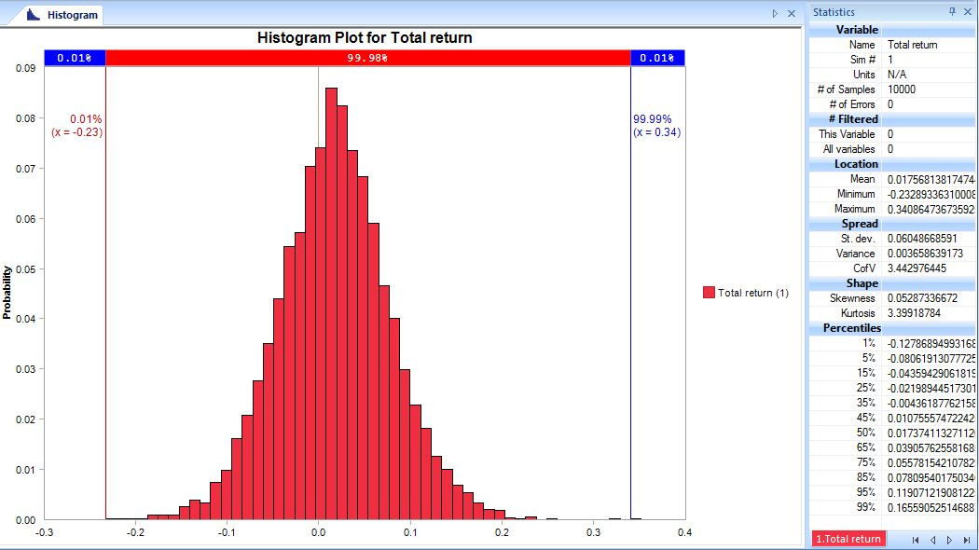

After overlaying three simulations, the plot looks like this.

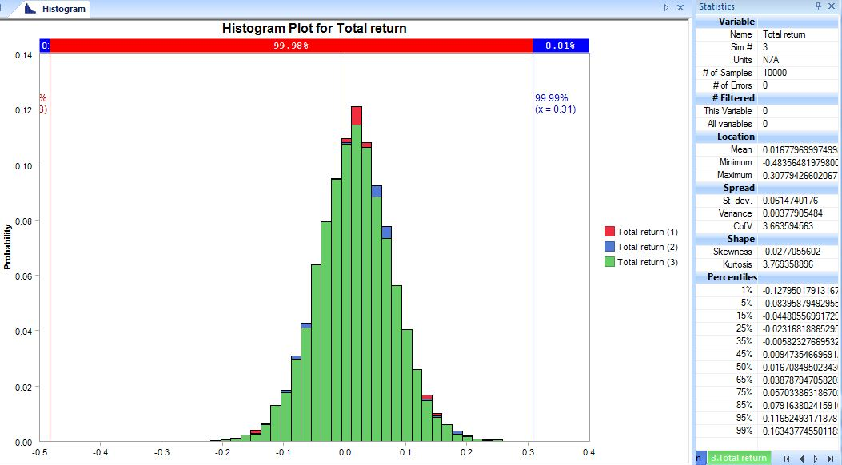

All the 3 vales are fairly close, the lowest being 0.01663 and highest being 0.01756. Hence, the ***total return*** expected from the portfolio is **1.6% to 1.7%.** Looking at the fractions invested in each stock of the portfolio we see that **57%** is invested in **TGT** as individually it gives the highest expected total return as noted in the total return table on page 15. **20.9%** is invested in **SHLD** and **9.8%** is invested in **JCP**. It might initially be surprising to see that only **12%** is recommended to be invested in **M** by the Optimizer as individually M has the second highest expected total return as noted in the total return table on page 15. However, on thinking through we recollect that from the correlation table on page 15, M and TGT had the highest correlation among the four companies. Therefore, in order to satisfy the constraint of not having a coefficient of variation greater than 30% for the portfolio, the optimizer recommends only 12% to be invested in M.

***Summary of fractions invested***

|  |  |  |  |  |
| --- | --- | --- | --- | --- |
| Fractions | SHLD | JCP | M | TGT |
| Invested by stock | 0.2093 | 0.0988375 | 0.12031489 | 0.57154761 |

## Time Series Models:

The disadvantage of a Monte Carlo simulation is that it ignores the temporal or time related nature of data. The failure to account for it would result in an inaccurate prediction that is far too uncertain. Ignoring the temporal pattern when analyzing and forecasting based on the data is a very common mistake in Monte Carlo simulation. Stock prices and the returns derived from the stock prices are temporal in nature. The stock prices and returns for the 4 companies considered follow a temporal pattern as shown below:

The adj. close stock prices in blue show a downward trend for SHLD and JCP. For M, there has been a dip in the adj. close after an upward trend. For TGT, the adj. close shows an upward trend.

But for returns the changes seem to fluctuate randomly around a mean close to zero. If there were clear trends that could be counted on continuing into the future, we would expect investors to have discovered them, acted on that knowledge (i.e., bought or sold the stock), and, as a result, destroyed the trend. For SHLD, occasional fluctuations in the returns can go to the order of 25% followed by JCP at about 22% and M at 15%. The least magnitude of fluctuations is for TGT at 8%.

Based on the above, we know that a time series needs to be fit to the returns data to account for these temporal patterns. The time series analysis has been done in the sheets below:



The time series appropriate for the 4 companies chosen is the Geometric Brownian Motion based on the various information criteria. These models assume that the natural log of the *changes* (i.e., log returns) in a variable between consecutive periods are independent and follow a normal distribution. These GBM models are sometimes referred to as “random walk models” since each step in the time series is calculated as a random change from the prior value. We fit a multivariate time series as we have 3+ returns to fit.

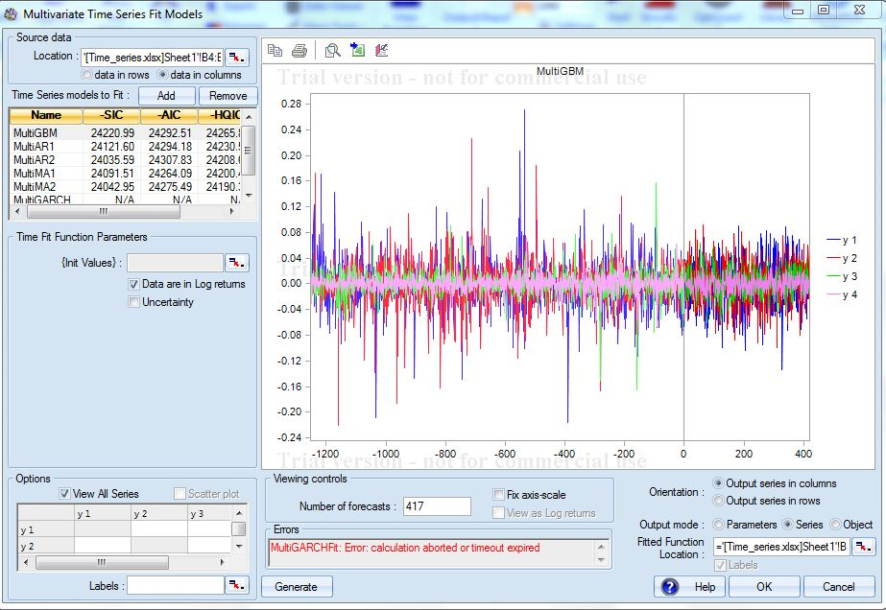

The multivariate time series also accounts for the correlation between the returns which can be viewed in the data viewer as shown below.

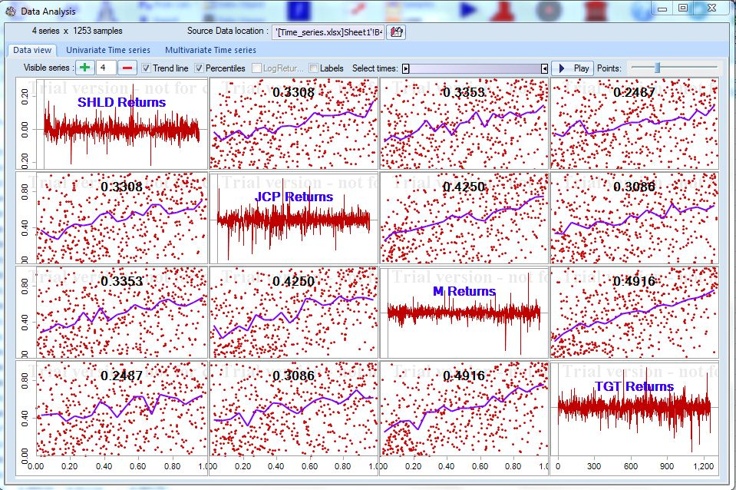

Amongst the 4 companies the strongest correlation is between M and TGT with a value of 0.4916. This correlation is similar to the one obtained by fitting copulas – 0.46367. The time series value is perhaps higher as it accounts for the temporal pattern in the data as well. The second highest correlation is between JCP and M with a value of 0.4250. This was not reflected when copulas were fitted.

It is good that the correlation is not higher than 0.49 as the aim of investing in a portfolio is that we hedge against risks. Even if one of the stocks falls, we hope another stock rises and makes up for it.

We can observe the highest correlation more closely using the following scatter plot.

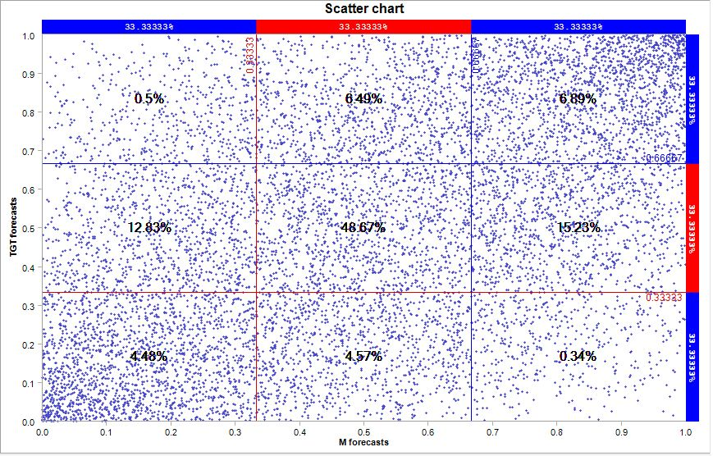

Most of the data is concentrated in the centre which indicates a strong positive correlation.

Using the time series, we predict the returns for the next 26 days (time periods). We use the last value as the final forecast and run a simulation for the 4 companies. The below line graph displays all the 4 companies in overlay mode.

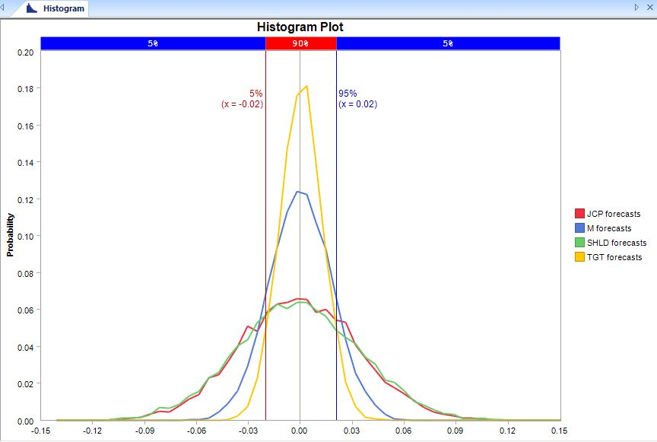

The above graph shows that the highest peak for TGT followed by M. SHLD and JCP have quite similar curves. We can also see that the curves of TGT and M are narrower than SHLD and JCP.

The statement above can be better explained using the following box plot. SHLD and JCP have high variances. TGT has the lowest variance followed by M. This variance could also be the result of the high fluctuations we saw in the returns of SHLD and JCP.

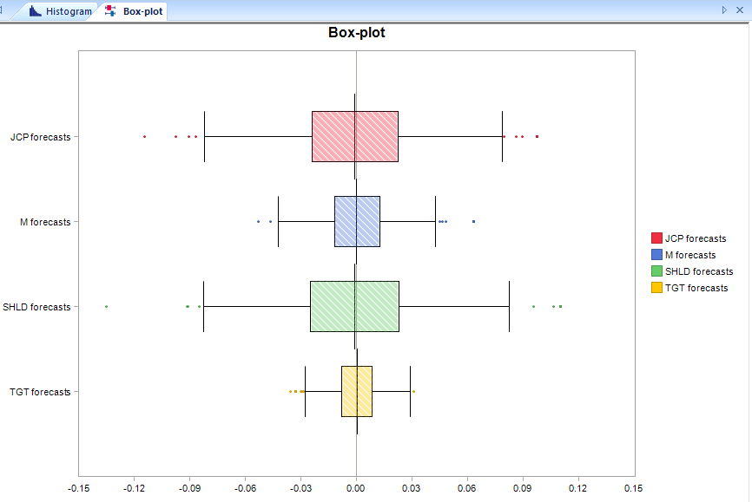

From the above simulation, we obtained the mean return and standard deviation for each company.

|  |  |  |  |  |
| --- | --- | --- | --- | --- |
| Company | **SHLD** | **JCP** | **M** | **TGT** |
| Mean return % | -0.100% | -0.095% | 0.016% | 0.048% |
| Std. dev % | 3.6% | 3.4% | 1.8% | 1.2% |

The above values will be used to decide the investments in these companies. So, we compute the stock prices from the returns using EXP and the previous closing price and then we calculate the shortfall (predicted price – actual price) to gauge the error/shortfall of our model. The risk output is below:



The trend plots for the 4 companies are as below:

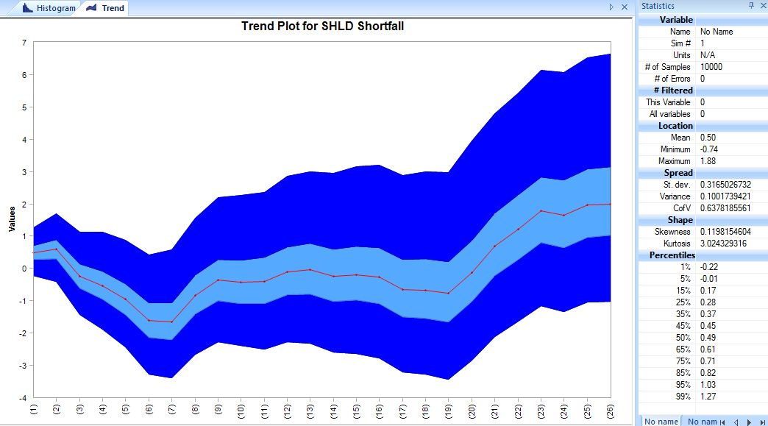

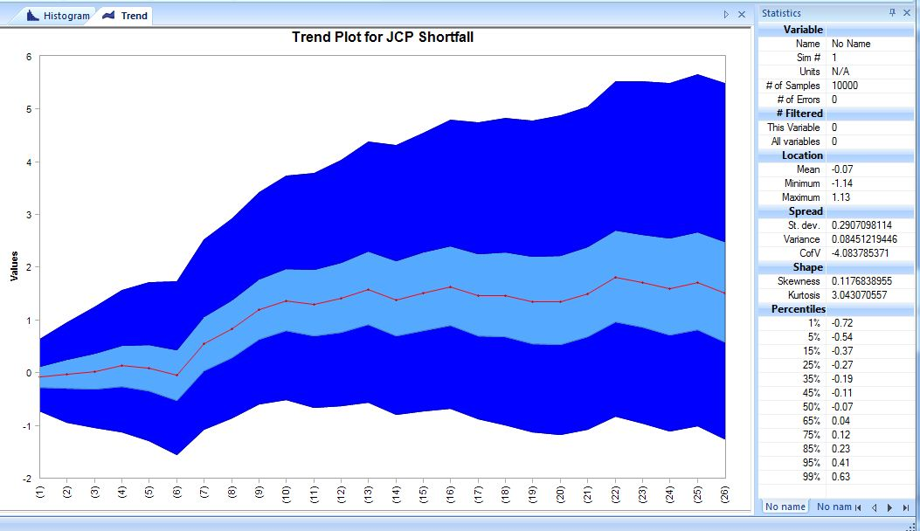

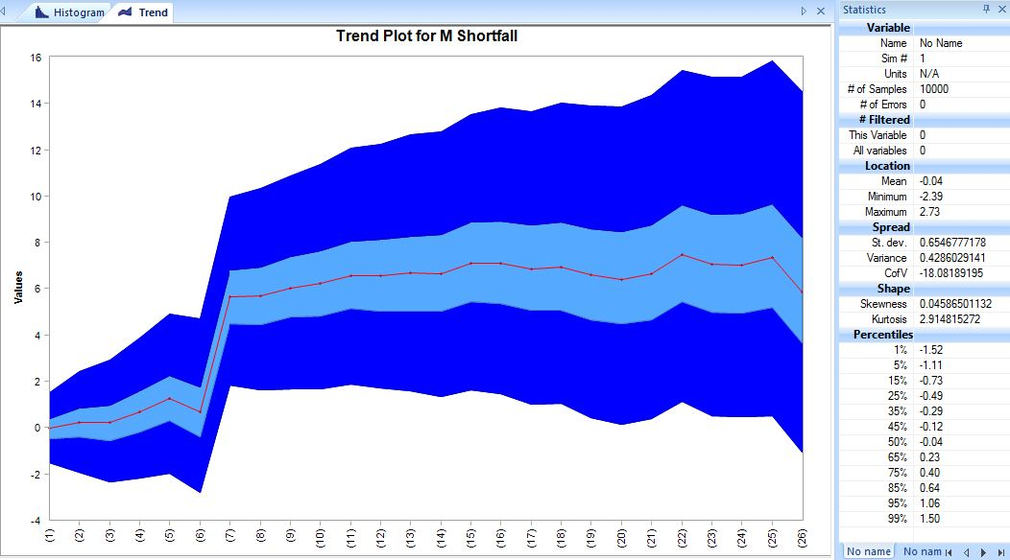

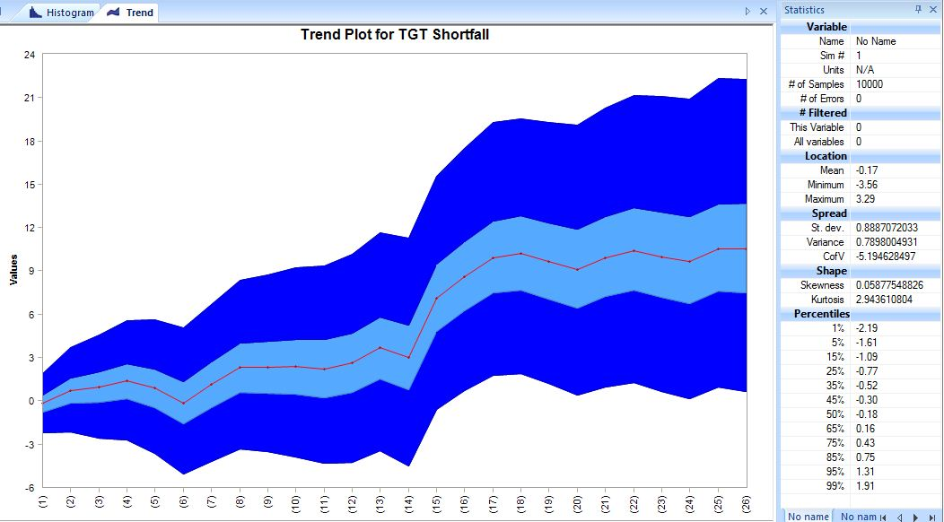

The absolute mean shortfall for all the companies is less than or equal to 50 cents.

|  |  |
| --- | --- |
| SHLD | 0.50 |
| JCP | -0.07 |
| M | -0.04 |
| TGT | -0.17 |

This indicates that our model is fairly accurate. However, there are higher values of shortfall towards the end of the period. This could be because of the sudden fluctuations that affect stock prices.

## Portfolio Simulation Using Solver:

We now use the Mean return and Std. deviation obtained from the simulation above to construct a portfolio using Excel Solver. The analysis is present in the sheet below:



We create a matrix of the companies, returns and std. deviations as below.

|  |  |  |
| --- | --- | --- |
| Expected Returns | | |
|  | Average Daily Return | Standard Deviation |
|  |
|  |
| SHLD | -0.10% | 3.56% |
| JCP | -0.09% | 3.41% |
| M | 0.02% | 1.80% |
| TGT | 0.048% | 1.23% |
|  |  |  |
|  |  |  |

The covariances are computed using excel’s data analysis toolpak.

|  |  |  |  |  |  |
| --- | --- | --- | --- | --- | --- |
| **Covariance Table** | | |  |  |  |
| **Weights** |  | 0% | 0% | 0% | 100% |
|  | **Asset** | SHLD | JCP | M | TGT |
| 0% | SHLD | 0.0013 | 0.0004 | 0.0002 | 0.0001 |
| 0% | JCP | 0.0004 | 0.0012 | 0.0002 | 0.0001 |
| 0% | M | 0.0002 | 0.0002 | 0.0003 | 0.0001 |
| 100% | TGT | 0.0001 | 0.0001 | 0.0001 | 0.0001 |
|  |  |  |  |  |  |
|  |  |  |  |  |  |
| *100%* |  | *0.0000* | *0.0000* | *0.0000* | *0.0001* |

The weights indicate the percentage invested in each stock that forms the portfolio. The portfolio statistics such as average return, std. deviation and slope are computed.

We then give a Target Average and use the solver to find the optimum portfolio mix subject to the following constraints:

* The sum of weights is 100%.
* Each weight is > 0%
* Target average = Average return

The portfolio mix of stocks for the various solver scenarios considered is as below:



The solver scenarios considered are as below:



The maximum possible return from this portfolio is 0.048%. So even if you give a higher target average the solver caps the average return at 0.048%. From the analysis done so far, we know that M and TGT have better returns as compared to SHLD and JCP. So, as we keep increasing the target average the percentage of the stock in M and TGT keeps increasing, finally reaching 100% in TGT.

The Efficient Frontier is plotted as below using the outputs from the solver scenarios shown above. As we have negative returns on two of the stocks, the efficient frontier curve has a long negative slope which means there are stocks with low returns and high std. deviations. It is not good to invest in these types of stocks.

## Conclusions from the Analysis:

The analysis concludes that TGT followed by M are good stocks to invest amongst the four at this time as they are doing much better than SHLD and JCP currently. This can be concluded by looking at each company’s internal performance from the income statement, external factors such as share price performance and their competitive environment. But if you are looking to build a portfolio using M and TGT it may not be a good option as M and TGT have the strongest correlation amongst the 4 companies.

Many a time operational and financial risks are looked at in isolation to judge a company’s future outlook. The correct way is to break silos and look at all forms of risk-operational, financial, strategic and compliance. As Figure 1 outlines, effective strategic risk management is built around a clear understanding of how much risk your business is prepared to take to deliver its objectives, and a timely and reliable evaluation of how much risk it is actually taking.

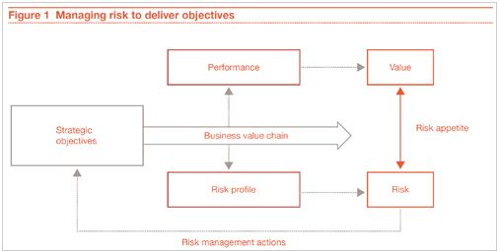

## Retail Outlook:

Looking from a macro perspective, traditional retail companies are going through a challenging phase right now. The Share price performance of the various retail companies can be summarized in the below matrix.

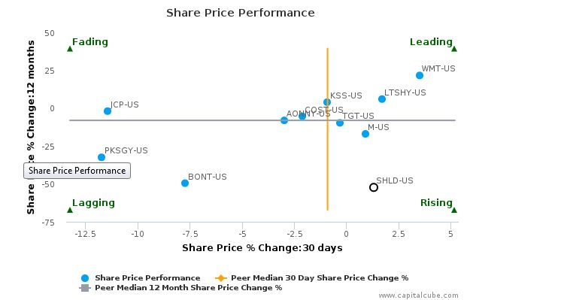

SHLD and JCP are closing stores to balance their asset ratio and improve liquidity. SHLD has negotiated deals for one of its famous brands and also plans to save $1 billion by restructuring. Hence the stock price of SHLD is in the rising quadrant whereas JCP is in the fading quadrant. M is at the top of the Rising quadrant. However, recent news is that Canadian Giant Hudson Bay is in talks to acquire M. If this happens, it will lead to mass store closings. It is possible that the stock price of M may fall. These recent happenings indicate that SHLD may have a comeback. Its share price rose 40% recently. TGT has been quite stable so far and hence looks to be a good investment.

|  |  |  |
| --- | --- | --- |
|  | Strengths | Risks |
| SHLD | Cheap store leases, Dealings on brands, Cost savings from restructuring, Share price rise | Lowest Projected Total value, Negative stock return, Mass store closings, Non-performing brands, Debt |
| JCP | Diversified supplier base, well known brands, affluent customer base, technology initiatives | Second lowest Projected Total value, Negative stock return, Mass store closings |
| M | Brand recognition, Economies of scale, Strong Management, Second highest projected Total value and stock return | May be acquired by another company, Mass store closings, High debt burden |
| TGT | Second largest retailer in U.S., Highest Total value and return, High profitability, Good Brand Image | Undiversified supplier base, no international penetration, legal cases |

The Risks facing the retail industry can be summarized as below:

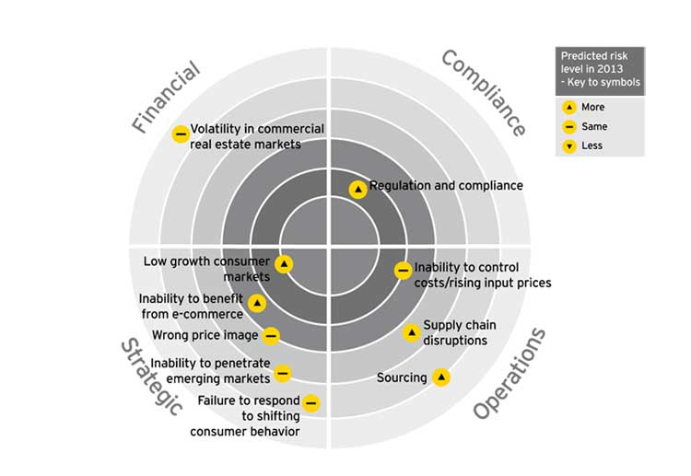

We have looked at operations and financial risk using income statements and VaR analysis. The other types of risks are an outcome of external factors that get reflected in the stock price, the competitive environment and in macro-economic factors.

**References:**

<http://www.marketwatch.com/investing/stock/shld/financials>

<https://ca.finance.yahoo.com/q?s=SHLD>

[http://www.ey.com/gl/en/industries/consumer-products/turn-risk-and-opportunities-into-results--retail-sector---the-top-10-risks](http://www.ey.com/gl/en/industries/consumer-products/turn-risk-and-opportunities-into-results--retail-sector---the-top-10-risks%20)

<http://www.pwc.com/gx/en/services/advisory/consulting/risk/resilience/publications/sharpening-strategic-risk-management.html>

<http://www.wikiwealth.com/swot-analysis>

<www.capitalcube.com>

Practical-Spreadsheet-Risk-Modeling-for-Management